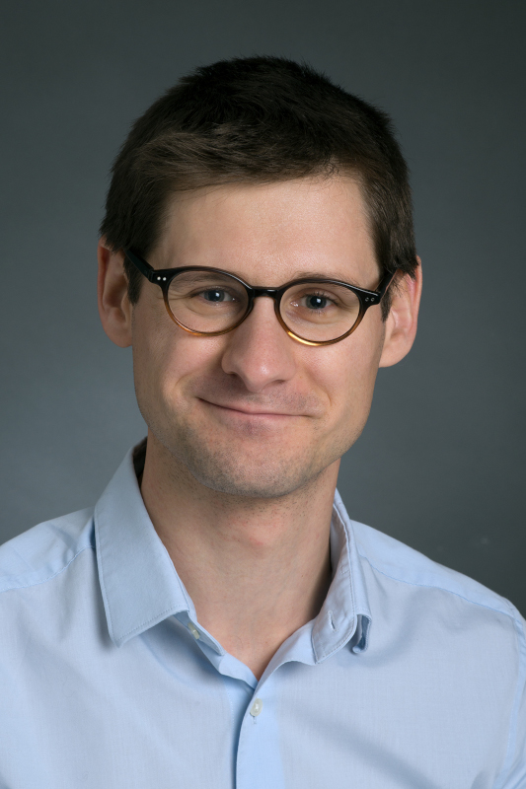

Guillaume Moulis

Guillaume Moulis is Associate Professor in Internal Medicine at Toulouse University hospital, south of France. He obtained his medical degree in Toulouse, France. He gives care to patients with general symptoms, autoimmune diseases, and particularly non-malignant hematological diseases like ITP and AIHA, Toulouse University hospital being one of the French referral centers for autoimmune cytopenia. He is also a researcher in epidemiology and pharmacoepidemiology. He obtained his MSc and PhD degrees in pharmacoepidemiology in Bordeaux and Toulouse, respectively. He did a post-doctoral fellowship in epidemiology at Aarhus University, Denmark. He developed cohorts of patients with ITP and AIHA in France (CARMEN clinical registry; FAITH and AHEAD cohorts within the French national health database) to better understand ITP and AIHA epidemiology, as well as the real world use, effectiveness and safety of ITP and AIHA treatments. Dr Guillaume Moulis has published 130+ research articles mostly in the field of non-malignant hematology (Blood, BJH, JTH…).

