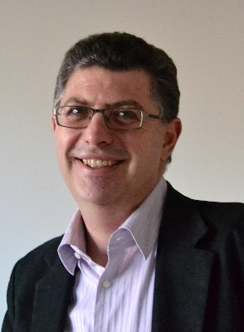

Waleed Ghanima
Waleed Ghanima is Head of Research and a Consultant Haematologist at Østfold Hospital, Norway. He is also a Professor in the Institute of Clinical Medicine at the University of Oslo, Norway. Dr. Ghanima gained his medical degree from the College of Medicine, University of Baghdad, Iraq. He joined Østfold Hospital in 2001, becoming a Consultant Haematologist in 2004, and he assumed his current position as Head of Research in 2014. Professor Ghanima’s main research field is venous thrombosis and immune thrombocytopenia (ITP). A member of several professional societies and was President of the Norwegian Society of Haematology 2013-2017. He has published numerous articles in national and international peer-reviewed in high rank journals including The NEJM, Lancet, Thrombosis and Haemostasis, Haematologica, British Journal of Haematology, Blood, Thrombosis Research.

