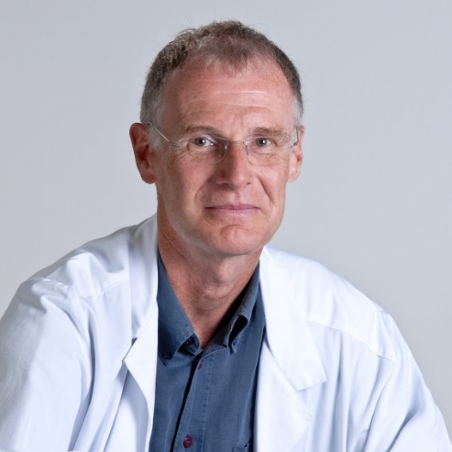

Thomas Kühne
Thomas Kühne is Professor of paediatric oncology and haematology and acting head of the Division of Oncology/Haematology at University Children’s Hospital in Basel, Switzerland. He obtained his medical degree and specialist certificates in paediatrics and paediatric oncology and haematology from the University of Basel. Professor Kühne is a board member of the Ethics Committee of Northwestern Switzerland, and a member of several professional societies in haematology and oncology. His main research interest is devoted to platelet physiology and pathophysiology with a special interest in paediatric aspects of immune thrombocytopenia. He published articles in journals and books on the natural history of children and adolescents with ITP and their management.

