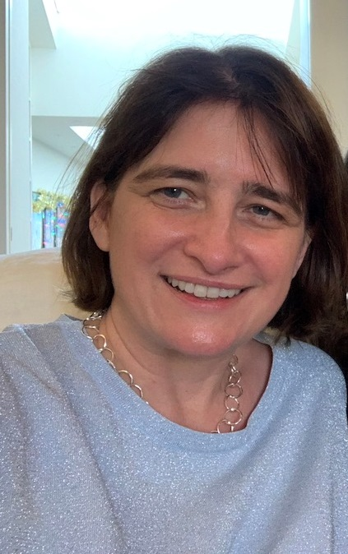

Nichola Cooper
Nichola Cooper is a Reader in immune haematology and Honorary Consultant Haematologist at Imperial College, Hammersmith Hospital, London, UK. She completed her undergraduate degrees at Cambridge University and Barts and the London Hospital Medical College, University of London, UK. During her haematology training, Dr Cooper undertook a research fellowship at Cornell Medical School, New York Presbyterian Hospital, USA, where she was involved with research into existing and experimental treatments in patients with ITP. Dr Cooper now runs a phase 1, 2 and 3 clinical trials program in ITP and a laboratory research programme investigating the genetic and environmental causes of haematological autoimmunity. She has authored many papers published in international, peer-reviewed journals including Nature Immunology, Blood, New England Journal of Medicine and the British Journal of Haematology.

