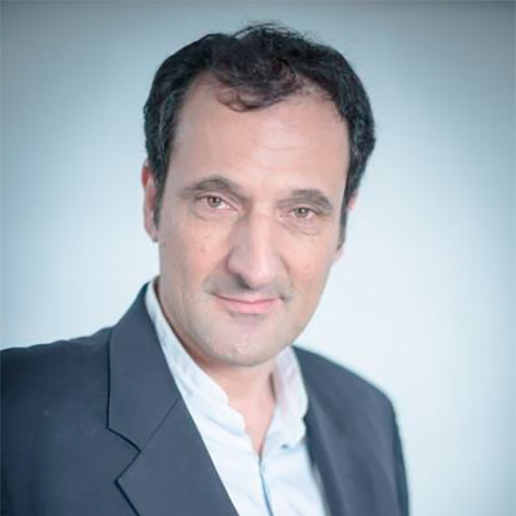

Marc Michel
Marc Michel, M.D, M.Sc, is a full Professor of Internal Medicine and the Head of the Unit of Internal Medicine, which is also the French national reference center for adult’s immune cytopenias (coordinator Prof B. Godeau), at Henri Mondor University Hospital, Université Paris-Est Créteil, Assistance Publique Hôpitaux de Paris, at Créteil, France. He is also the head of the Division of Internal Medicine – Geriatrics-Endocrinology and Emergency Unit, at Créteil. He did his medical school, his residency and training in Paris (internal medicine, hematology and clinical immunology). He spent 2 years doing research in Immunology at INSERM U25, Faculté de Médecine Necker (Pr. Jean-François Bach) in Paris and spent a year at the Platelet research center (head Prof. JB Bussel) at the New York Presbyterian Hospital, Weill Medical College of Cornell University, New York. He has a recognized clinical expertise in auto-immune diseases and especially in ITP and autoimmune hemolytic anemias. He has participated as an investigator to several clinical trials and is an active member of both the European working group on thrombocytopenias and the international ITP working group. He has contributed to the development of new standards in ITP terminology and the consensual ITP bleeding assessment scale and he is the author or co-author of many peer-reviewed articles especially on adult immune cytopenias. He has also an expertise in red blood cell disorders beside AIHA and especially in sickle cell anemia and in other acquired forms of hemolytic anemia such as paroxysmal nocturnal hemoglobinuria (PNH).

