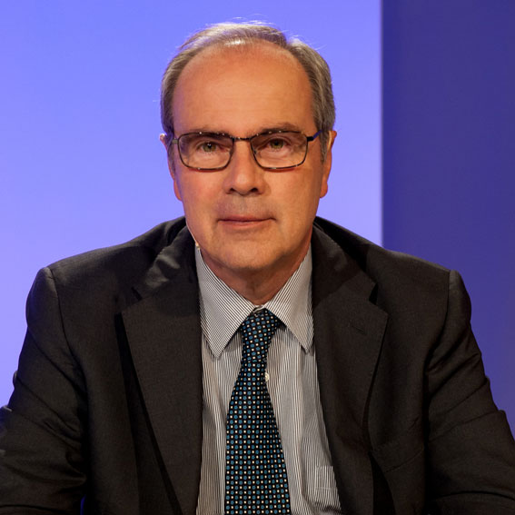

Francesco Rodeghiero
Francesco Rodeghiero is the Scientific Director of the Hematology Project Foundation, a non-profit organization for scientific research based in Vicenza, Italy. Previously, he has directed for 25 years the Hematology Department of the San Bortolo Hospital in Vicenza. He has been Professor at the Postgratuated School of Hematology of the Verona University, Italy. He has been in the board of several national and international scientific societies, such as the Italian Society of Hemostasis and Thrombosis, the European Hematology Association, the International Society on Thrombosis and Hemostasis - also as Chairman of its Scientific and Standardization Committee. He is Associate Editor of Haematologica and of eJHaem. His main interests include hemophilia and von Willebrand disease, myeloproliferative disorders and thrombocytopenias. In the last two decades his main research interest has been devoted to ITP. He is author or co-author of more than 455 papers published in international, peer-reviewed journals.

